

**Deccan Education Society’s**

# Fergusson College (Autonomous), Pune

**Department of Computer Science**

**A**

**Report**

**On**

# Industrial Training

At

# ELENDIL

In partial fulfillment of the requirements for the degree of **Master of Science (Computer Science) - II CSC5401 Industrial Training/Industrial Project**

Submitted By

# ASHWINI R. JAWALE (226237)

[2023-2024]

**CSC5401 Industrial Training**

**CERTIFICATE**

This is to certify that **Ms. ASHWINI R. JAWALE** Roll No. 226237, has Satisfactorily completed the Industrial Training at “ELENDIL” towards the partial fulfillment of M.Sc. (Computer Science) – II, Semester IV during the academic year 2023-2024.

Place: Pune Date: / /2022

#### Dr. Kavita Khobragade

**Head,**

#### Department of Computer Science Fergusson College (Autonomous), Pune

**Mr. Irfan Khatik**

**(Guide)**

**ACCEPTANCE**

This is to certify that the undersigned have assessed and evaluated the industrial training report submitted by **Ms.** **ASHWINI RAJENDRA JAWALE** exam seat no. 226237. The report has been accepted for the partial fulfilment of the degree of M.Sc. (Computer Science) for the academic year 2023-2024, from Deccan Education Society’s Fergusson College (Autonomous), Pune affiliated to Savitribai Phule Pune University, Pune.

##### Industrial Expert

Name :

Signature :

##### Examiner

Name :

Signature :

Place :

Date :

### ACKNOWLEDGEMENT

I convey my gratitude to the **ELENDIL** for providing me this opportunity to work as an intern and for providing me good training. I would like to express my sincere thanks to my project manager, **Mr. Abdul Aleem Heroli** and development team for their guidance and valuable suggestions without which this project would not have been possible.

I am grateful to my project guide **Mr. Irfan Khatik** for his help, guidance and valuable suggestions throughout the tenure of this project.

# Index

|  |  |  |  |
| --- | --- | --- | --- |
| **Sr. No** | | **Table of Content** | **Page No** |
| **1.** |  | **Company Profile** | 6 |
|  | a. | Company Overview | 6-7 |
|  | b. | Services | 8-10 |
|  | c. | Products | 11-12 |
| **2.** |  | **Introduction** | 13 |
|  | a. | Overview | 13 |
|  |  | i.Existing System | 13-14 |
|  |  | ii.Need of the System | 13 |
|  |  | iii.Overview of the Project | 14-15 |
|  | b. | Detail Description of Hardware and Software Requirements. | 16 |
| **3.** |  | **System development LifeCycle** | 17 |
|  | a. | Requirements from User | 17 |
|  | b. | Feasibility Study | 18 |
|  |  | i.Technical Feasibility | 18 |
|  |  | ii.Operational Feasibility | 19 |
|  |  | iii.Time Feasibility | 20 |
|  | c. | Analysis | 21 |
|  |  | Components | 21-22 |
|  |  | **Project-I** | 23-26 |
|  |  | **Project-II** | 27-29 |
|  |  | **Project-III** | 30-34 |
|  |  | **New Technologies Learnt** | 35-39 |
|  |  | **Testing** | 40 |
|  |  | i.Importance of Testing | 40 |
|  |  | ii.Types of Testing and Test Cases | 41-42 |
| **4.** |  | **Drawbacks and Limitations** | 43 |
| **5.** |  | **Future Enhancement and Conclusion** | 44-45 |
| **6.** |  | **Bibliography** | 46 |

**1.COMPANY PROFILE**

#### Company Overview:

**ELENDIL** is a dynamic and forward-thinking service-based startup specializing in transforming ideas into intelligent, cutting-edge solutions. It provides various AI services that range from AI Model Development designed for superior performance in image, text, to transforming Android devices into intelligent companions by bringing unparalleled intelligence of Android AI applications to the palm of your hand. We specialize in creating high-end AI driven chatbots on your own data, and websites and mobile apps too. We do excel in data analytics too, right from creating useful interactive dashboards to analyzing large documents. Last but not the least we also help companies gather more clients by advertising their contents on various platforms and promoting their product with trending SEO keywords as well.

**Mission:**

The mission of Elendil is to empower businesses and individuals by leveraging the latest advancements in AI technology. They aim to drive innovation that not only addresses current needs but also anticipates and adapts to future challenges. Elendil's commitment lies in delivering solutions that significantly impact efficiency, productivity, and user satisfaction.

**Core Values:**

**Innovation:** Elendil is dedicated to pushing the boundaries of what is possible through innovative solutions and technologies.

**Expertise:** With a team of dedicated experts, Elendil ensures the highest level of proficiency in delivering quality products and services.

**Technology-driven:** The company prioritizes the use of cutting-edge technology, particularly AI, to create impactful solutions.

6

**Customer Empowerment:** Elendil aims to empower businesses and individuals

by providing them with tools and solutions that enhance their capabilities.

Future-focused: Anticipating and adapting to future challenges is a key aspect of Elendil's approach to innovation and development.

7

#### Services:

1. **Document Reader**: Allows users to upload documents and extract text and key information, enabling easy data analysis and processing.
2. **Describe / Caption Images**: Uses AI to generate captions and descriptions for images, providing context and insights.
3. **Inspect Images**: Analyzes images for patterns, objects, or other features, offering valuable insights for various use cases.
4. **Generate Audio**: Synthesizes audio content from text inputs, allowing users to create voice recordings or spoken presentations.
5. **Transcribe Audio / Speaker Diarization**: Converts spoken audio into text and identifies different speakers, enabling easy data extraction and analysis.
6. **Generate Text Content**: Uses AI to generate written content based on user input, aiding in content creation and copywriting.
7. **Generate Images**: Produces custom images based on user prompts, facilitating design and visual content creation.
8. **Generate Videos**: Synthesizes videos using user inputs, making it easy to create multimedia content.
9. **Chatbots on User Defined Data**: Develops chatbots using user-provided data, allowing for personalized and context-aware interactions.
10. **Predictive Analysis**: Uses data and AI algorithms to make predictions and forecasts, supporting decision-making.
11. **AI Search Engine**: Provides an AI-driven search experience that understands context and user intent, offering more relevant results.
12. **Querying Database**: Allows users to query databases using natural language, simplifying data retrieval.

8

1. **Document Examiner**: Analyzes documents for content, patterns, and anomalies, supporting data verification and quality control.
2. **SQL Query Generator**: Automatically generates SQL queries from user inputs, enabling quick and efficient database interactions.
3. **Community for Builders**: Offers a platform for AI enthusiasts and developers to collaborate, share insights, and build projects together.
4. **AI Code Assistant**: Provides code suggestions and assistance for developers working with AI, streamlining the coding process.
5. **Regex Assistant**: Helps users create and test regular expressions, making text parsing and validation tasks easier.
6. **Database Assistant**: Assists users with database-related tasks, including management, queries, and optimization.
7. **Figma Designs**: Offers tools to integrate and work with Figma designs, enabling design and AI collaboration. `
8. **Generate Music**: Uses AI to create musical compositions based on user input or parameters.
9. **Combining Services**: Enables users to combine different AI services in custom workflows, allowing for innovative solutions and applications.
10. **Community for Builders**: Offers a platform for AI enthusiasts and developers to collaborate, share insights, and build projects together.
11. **AI Code Assistant**: Provides code suggestions and assistance for developers working with AI, streamlining the coding process.
12. **Community for Builders**: Offers a platform for AI enthusiasts and developers to collaborate, share insights, and build projects together.

9

1. **Community for Builders**: Offers a platform for AI enthusiasts and developers to collaborate, share insights, and build projects together.
2. **AI Code Assistant**: Provides code suggestions and assistance for developers working with AI, streamlining the coding process.
3. **Regex Assistant**: Helps users create and test regular expressions, making text parsing and validation tasks easier.
4. **Database Assistant**: Assists users with database-related tasks, including management, queries, and optimization.
5. **Figma Designs**: Offers tools to integrate and work with Figma designs, enabling design and AI collaboration. `
6. **Generate Music**: Uses AI to create musical compositions based on user input or parameters.
7. **Combining Services**: Enables users to combine different AI services in custom workflows, allowing for innovative solutions and applications.

10

#### Products:

1. **MomAge** ensure a healthier maternity experience, employing AI to monitor physical health and provide essential emotional and psychological support from conception to the baby.



1. **Irava**  harnesses artificial intelligence to address and mitigate pregnancy-related health issues and is dedicated to safeguarding both maternal health and the well-being of unborn children.



11

1. **Finright** uses AI driven chatbot solution. It empowers users with real-time, intelligent

responses to investment-related queries, delivering seamless and informed interactions.

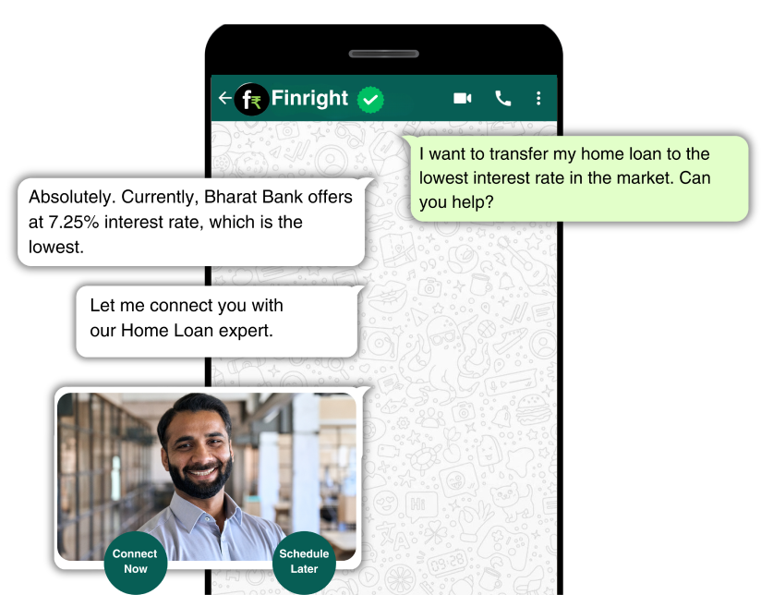

12

**2.INTRODUCTION**

1. **Overview**

#### Existing System:

#### Current AI services pose significant barriers for small and medium-sized businesses due to high costs and complex implementation processes. Many platforms offer AI capabilities at premium prices, making them less accessible. Integrating these services with existing systems is challenging and time-consuming. The learning curve for using AI models effectively is steep, requiring specialized knowledge. Thus, many organizations struggle to fully leverage AI's potential, hindering innovation and growth.

#### Need of the System:

#### The necessity for a unified AI services system arises from the widespread demand for AI technologies that are accessible, cost-effective, and user-friendly across different industries. Many businesses, particularly small and medium-sized enterprises, encounter obstacles when trying to adopt AI solutions due to their high costs, complexity, and the expertise required. A system that brings together AI services at competitive prices and offers intuitive interfaces can empower organizations to utilize advanced technologies without hefty investments or specialized technical knowledge. By providing a comprehensive platform that simplifies the integration of AI, businesses can enhance their operations, make better decisions, and foster innovation. Moreover, a centralized system streamlines the development process, saving both time and resources, and promotes collaboration and growth within the AI ecosystem.

13



#### Overview of the Project:

The **"Home of AI Services"** initiative offers a centralized platform that delivers an array of AI services to users at an economical and streamlined cost. Key elements of the project encompass:

• **Identity Verification and User Administration:** Users can access the platform through email/password or Google authentication. A registration portal facilitates new user sign-ups, with robust password recovery mechanisms ensuring account security.

• **Simplified Navigation:** Intuitive navigation tools, such as a user-friendly menu bar, enable seamless exploration of diverse services like Textual Data, Visual Insights, and Audio Analysis.

• **Seamless AI Integration:** The platform seamlessly integrates various AI services, spanning text processing, image recognition, and audio analysis, all within a unified interface.

• **Efficient Service Management:** Users enjoy streamlined management of AI services, encompassing creation, modification, and monitoring of services tailored to individual requirements.

• **Secure Communication Channels:** Encrypted messaging features enable users to engage in collaborative efforts and discussions on AI projects, fostering a supportive community atmosphere.

14

• **Task Scheduling and Coordination:** Users can efficiently organize and oversee AI services and tasks through scheduling functionalities, ensuring optimized workflow and productivity.

• **Personalized Settings:** Users have the flexibility to personalize their platform experience, adjusting profile settings and accessing convenient logout options.

The overarching objective of the **"Home of AI Services"** initiative is to democratize access to advanced AI technologies, making them more accessible and cost-effective for a diverse user base. By simplifying the adoption and integration of AI into various applications, the project aims to facilitate innovation and progress across industries.

15

#### Detail description of Hardware and Software requirement:

* **Hardware Requirements:**

##### Mobile Device:

* Android or iOS smartphone or tablet capable of running React applications.

##### Recommended specifications:

* Android: Devices running Android 5.0 or higher and minimum 2GB RAM, 1.5GHz processor.
* iOS: Devices running iOS 10 or higher, including iPhones and iPads.
* **Software Requirements:**

##### Development Environment:

* React App: The latest version of React App installed on the development machine.
* Integrated Development Environment (IDE):
  + Preferred: Visual Studio Code (with Node JS and TypeScript Installed).
  + Alternatively: Other IDE capable of Deployment of the Project. Operating System: Windows, macOS, or Linux.

##### Dependencies and Packages:

* Firebase SDK: Required for integrating Firebase services such as authentication and database.
* Google Sign-In Plugin: Plugin for implementing Google authentication.
* Other necessary React packages for UI design, state management, and navigation.

##### Backend Services:

* Firebase Authentication: For user authentication via email/password and Google.
* Firebase Realtime Database or Cloud Firestone: For storing user data, appointments, prescriptions, and patient information.

16

**3. SYSTEM DEVELOPMENT LIFECYCLE**

1. **Requirements from User:**

* Users should possess fundamental computer literacy.
* Users should be proficient in navigating mobile applications.
* Users should have reliable internet connectivity.

17

#### Feasibility Study:

Feasibility assessment is a process aimed at evaluating the viability of system development. It involves examining the availability of financial and technical resources necessary for the project's execution.

There are three primary ways to assess feasibility:

* + Technical Feasibility.

##### Operational Feasibility.

* + Time Feasibility.

##### Technical Feasibility:

* **Cross-Platform Compatibility:** This approach minimizes development complexities and costs associated with platform-specific development.
* **Simplifying Operations with Firebase Integration**: Leveraging Firebase facilitates seamless integration of robust authentication and database functionalities, simplifying user management and data storage requirements without incurring significant development efforts.
* **Leveraging Third-Party Solutions:** The availability of third-party libraries for UI components, Google Sign-In integration, and other essential functionalities accelerates development timelines and minimizes resource investments.
* **Ensuring Scalability:** React's inherent scalability features enable applications to effortlessly expand and adapt to evolving requirements, ensuring sustained performance and usability even as user demand increases over time.

18

##### Operational Feasibility:

##### User Adoption Potential: The application caters to essential requirements within the IT sector, enhancing user experiences and optimizing operational workflows. Its alignment with industry demands suggests a strong likelihood of user acceptance and adoption.

##### Training Demands: The platform's intuitive design and familiar features, such as streamlined signup processes and user-friendly dashboards, mitigate the need for extensive training sessions. This accessibility ensures quick onboarding for both novice and experienced users.

##### Integration with Existing Infrastructure: Seamless integration with established AI services platforms enables smooth data interchange and operational synergy. This capability enhances overall efficiency by leveraging existing infrastructure investments and facilitating collaborative workflows.

##### Scalability Planning: Assessing the application's scalability potential ensures its ability to accommodate future growth and evolving user demands. By proactively addressing scalability concerns, the platform can maintain operational viability amidst changing requirements and expanding user bases.

19

##### Time Feasibility:

##### Accelerated Development: React's utilization of component-based architecture and extensive library resources expedites development and iteration, yielding considerable time savings compared to conventional methodologies.

##### Efficient Deployment and Testing Procedures: The seamless integration of React with contemporary CI/CD pipelines and testing frameworks, complemented by Firebase's deployment utilities, optimizes testing processes and expedites deployment, facilitating swift transitions from development to production environments.

##### Continuous Enhancement: Embracing an agile, iterative development paradigm within React fosters ongoing improvements and feature enhancements post-launch. This iterative approach ensures the "Home of AI Services" project remains dynamic and responsive to evolving user demands, sustaining its competitive edge in the market landscape.

##### Time-to-Market Considerations: React's efficient development and deployment capabilities contribute to shortened time-to-market, enabling the project to swiftly capture market opportunities and deliver value to end-users.

20

#### Analysis:

* **Components:**
* **Authentication Component:**  Manages user authentication via email/password and Google Sign-In, encompassing functions for registration, login, and password retrieval. Additionally, implements security measures such as two-factor authentication for enhanced account protection.
* **Service Management Component:** Enables users to oversee various AI services like Document Reading, Image Description/Captioning, Image Inspection, Audio Generation, Audio Transcription, Speaker Identification, and sentiment analysis. Users can create, update, and monitor services as per their requirements, with options for service customization and optimization.
* **Profile Management Component:** Facilitates profile creation, viewing, and updating, gathering crucial details such as organizational affiliation, user preferences, and usage history. Offers features for profile privacy settings and data management preferences.
* **Integration Component:** Streamlines integration with Internet of Things (IoT) devices, third-party APIs, and external services like Google Sign-In, social media platforms, and cloud storage solutions. Provides seamless data exchange and interoperability for enhanced functionality and user experience.
* **Data Management Component:** Grants access to user data and histories, facilitating efficient data management, analysis, and visualization. Offers advanced querying capabilities, data filtering options, and AI-powered insights generation for informed decision-making.

21

* **Messaging Component:** Implements a secure messaging framework for real-time user communication, with features for group messaging, file sharing, and multimedia support.

Integrates with AI-driven chatbots and virtual assistants to enhance user interactions and support services.

* **Content Generation Component:** Empowers users to create custom content, including text, images, and videos, leveraging AI services like Content Generation, Image Creation, Video Generation, Music Generation, and Service Combination. Provides templates, presets, and editing tools for content customization and personalization.
* **Analytics Component:** Provides comprehensive insights and analytics derived from AI service utilization, including performance metrics, usage trends, and user behavior analysis. Offers predictive modeling, anomaly detection, and recommendation systems for proactive decision support.
* **Community and Collaboration Component:** Establishes a platform for user interaction, knowledge sharing, and collaborative AI project endeavors. Facilitates user forums, discussion groups, and community events to foster engagement and collaboration among users.
* **Personalized Settings Component:** Enables users to personalize platform settings, manage notifications, and administer account preferences for a tailored user experience. Includes options for language preferences, accessibility settings, and theme customization.



**          PROJECT-I**

The project titled **‘AI SERVICES AT GLANCE’** dwells into making AI Services available for customers at a cheaper and effective cost. Providing various LLM features as a service to clients. It provides easy interface for the clients to come and acquire various LLM features.

**Input/Output Screen:**

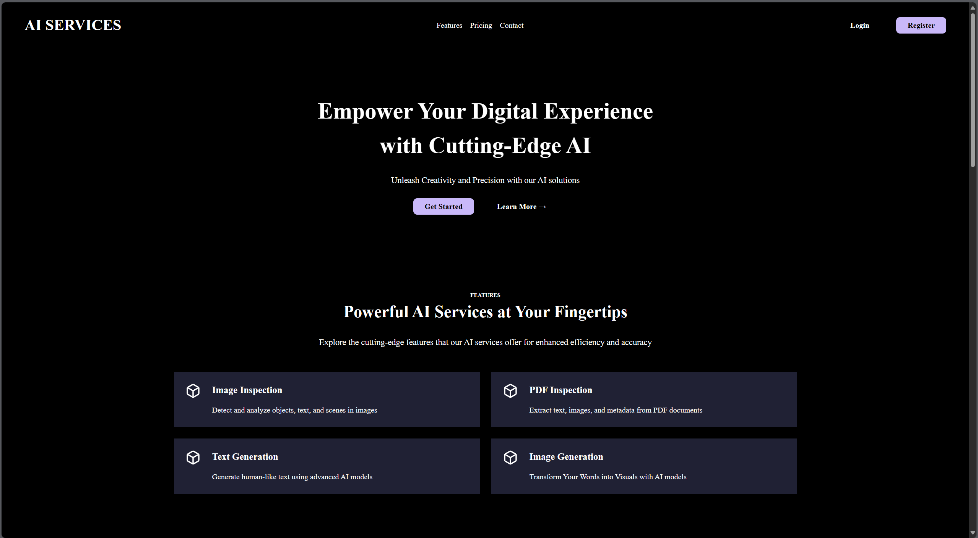

23

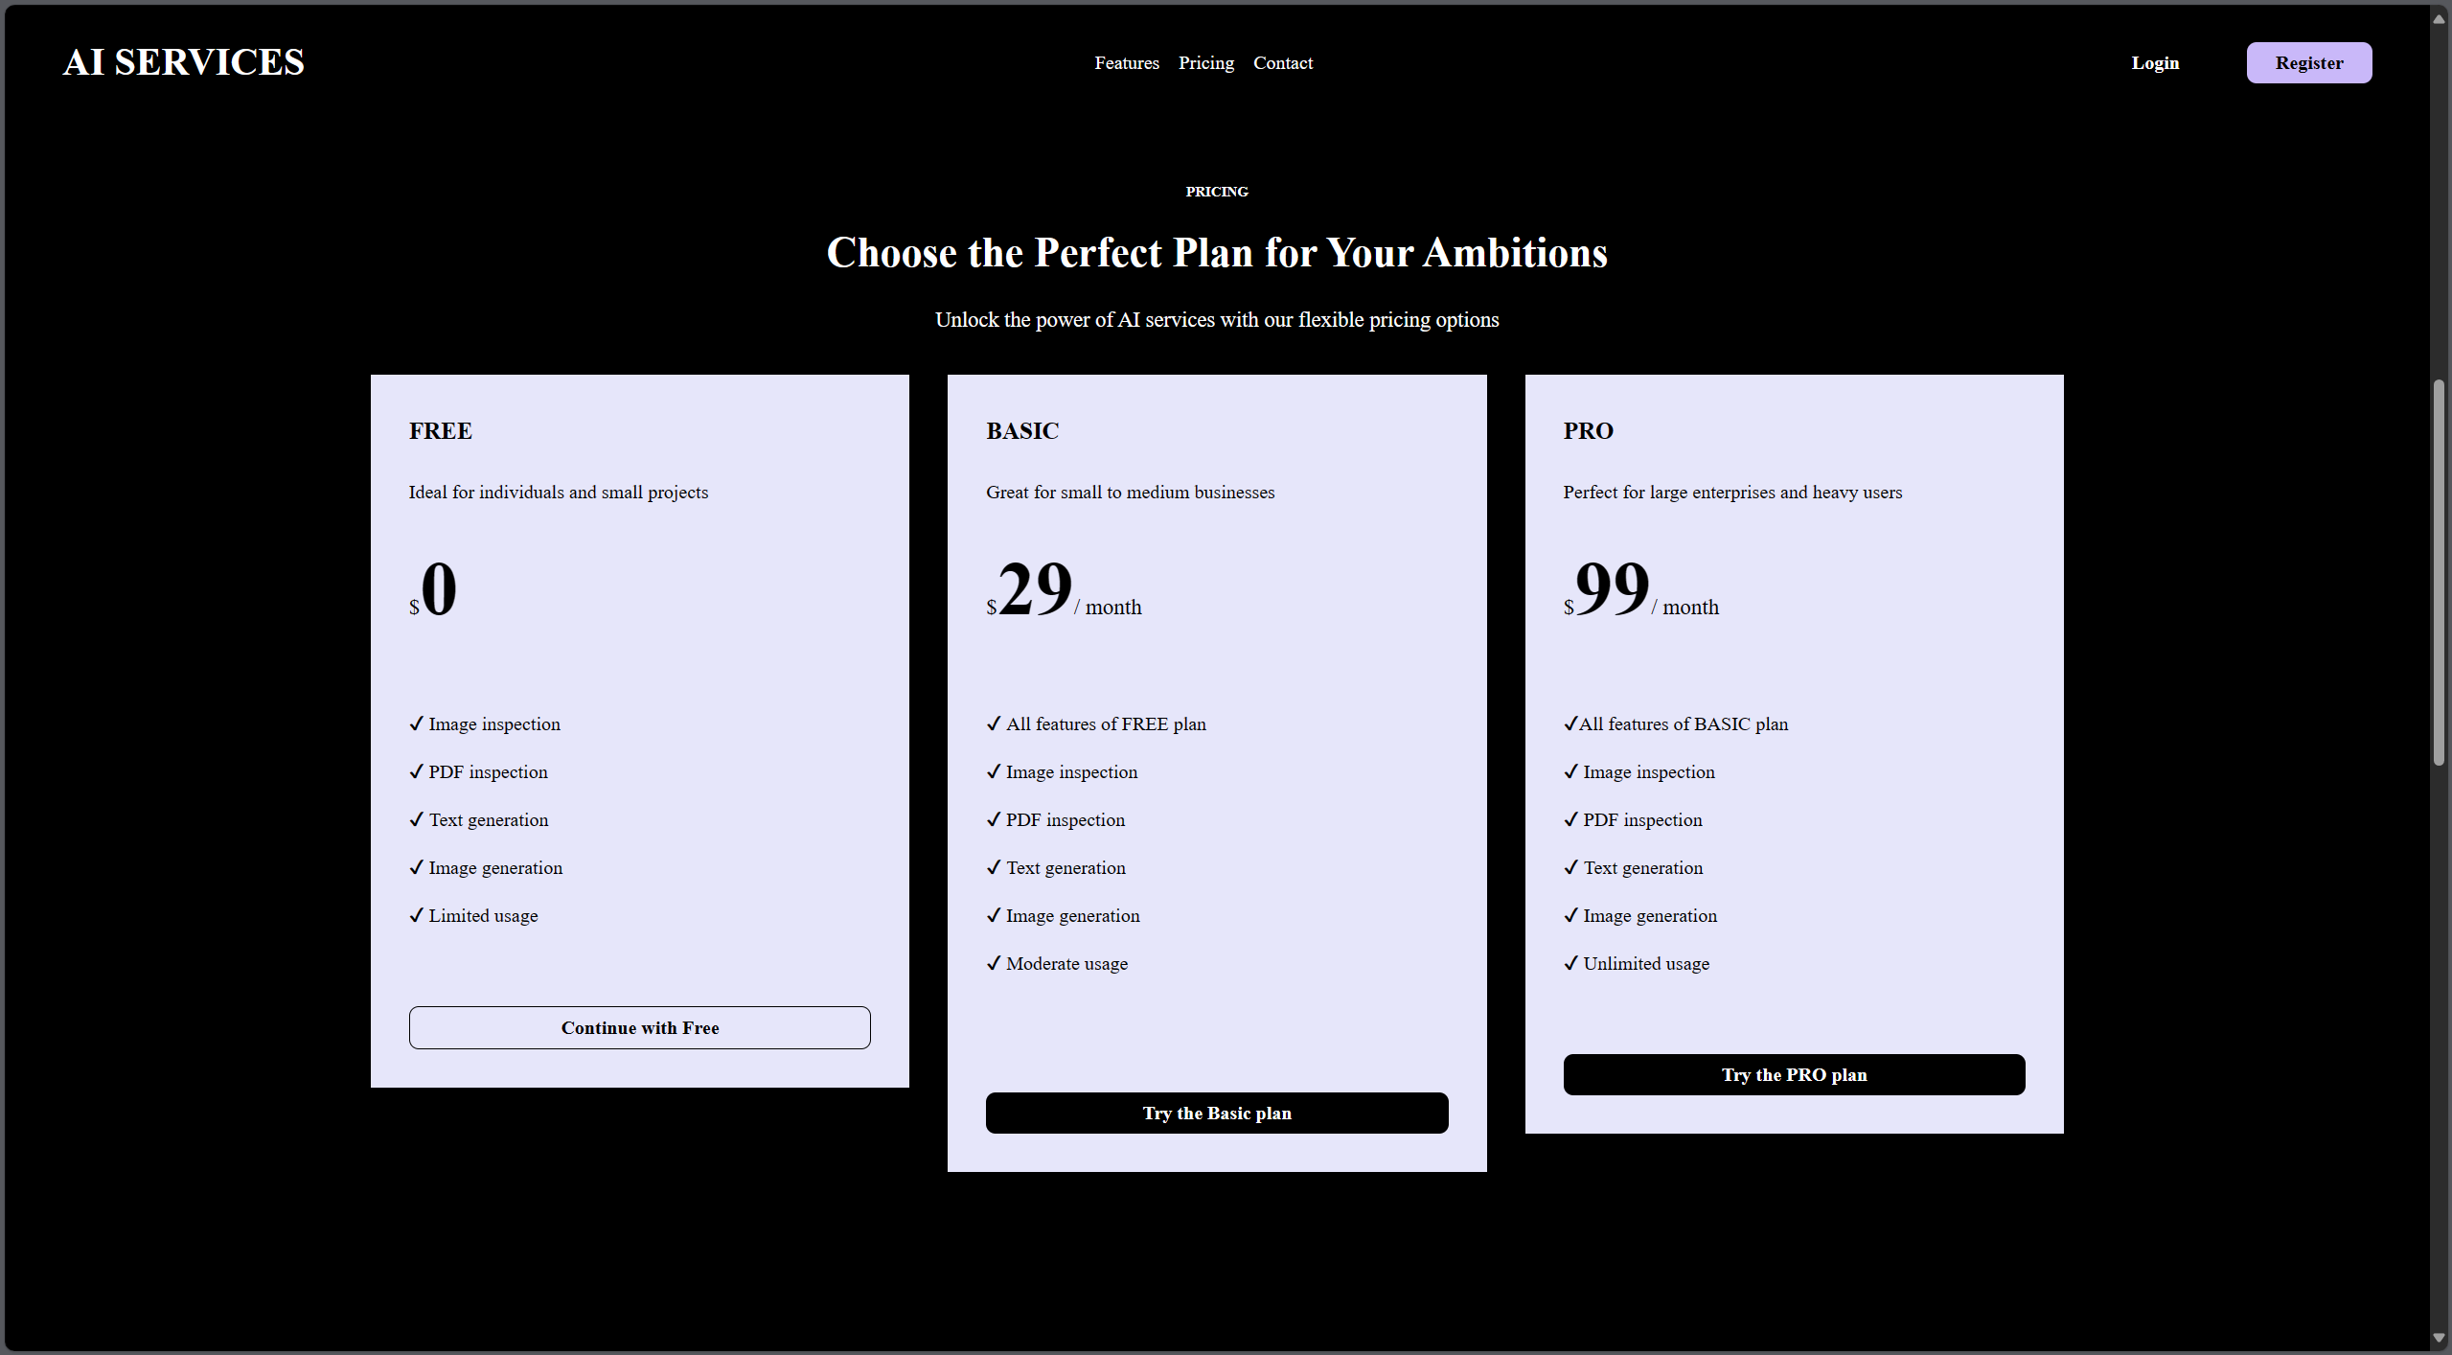

24

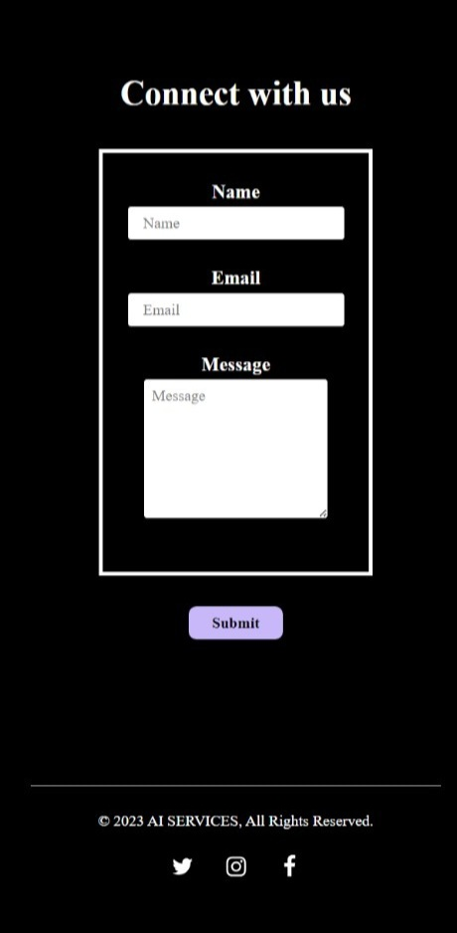

25

**My Contribution:**

Worked on Frontend technologies and UI with the Frontend team using React JS, firebase. Designed Company’s Introduction page/Landing page. The main components were –

* **Login**
* **Services**
* **Pricing**
* **Products**
* **About**
* **Client/User - Form**

And then deployed it on firebase.

**Technology used:**

* React JS
* Firebase
* GeminiLLM Model (Backend AI APIs)

26

**PROJECT-II**

The project titled **‘AAFIYA – MEDICAL DIAGNOSTICS’** utilizes state of Art Deep Learning and AI Models to diagnose cancer and other deadly diseases. So, to help identify cancers and other disorders at early stages so as to effectively treat them.

**Input/Output Screen:**



27

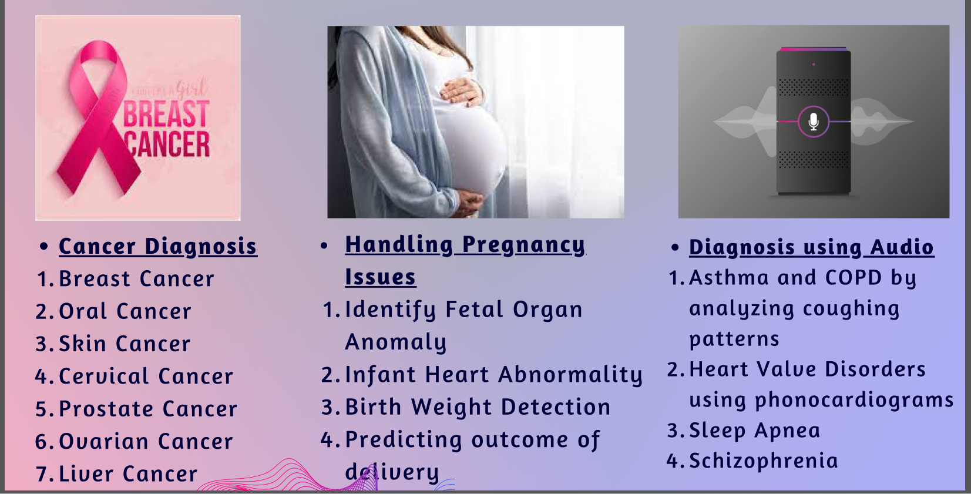

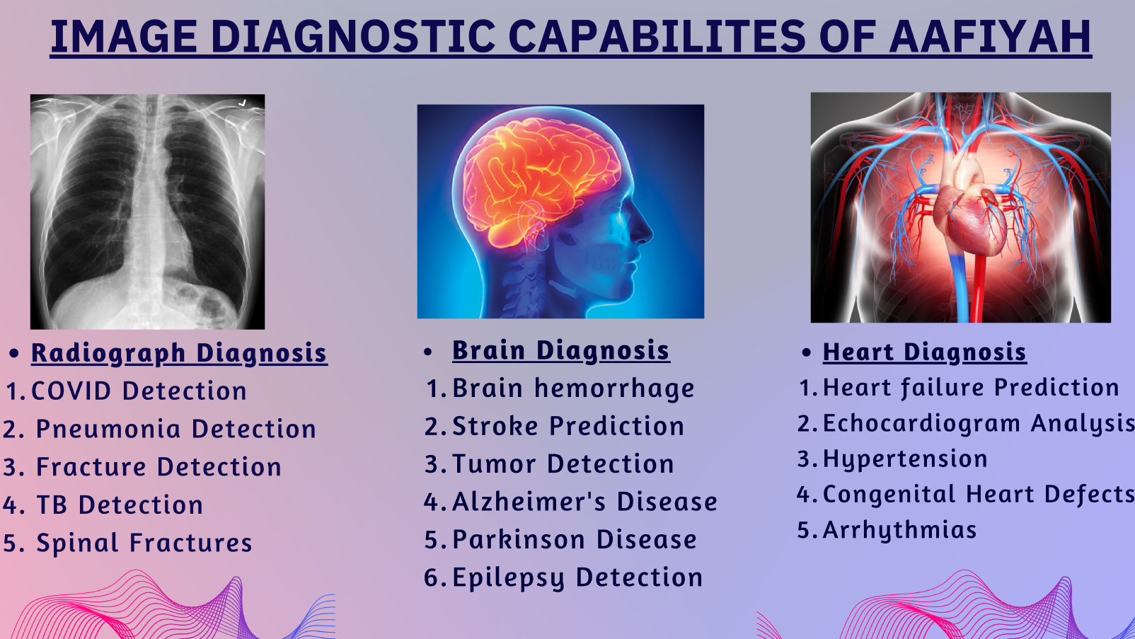

28

**My Contribution**

Worked on Frontend technologies and UI using React JS, firebase. Designed the Project’s Introduction page/Landing page where there are various categories of diagnosis such as –

* **Cancer Diagnosis**
* **Handling Pregnancy Issues**
* **Diagnosis using Audio**
* **Radiograph Diagnosis**
* **Brain Diagnosis**
* **Heart Diagnosis**

**Technology used:**

* React JS
* Firebase
* Routing Libraries (React Router)

29

**PROJECT-III**

The project titled **‘Chatbot Service’**, that intends to help clients with question and answering over their own dataset, thus increasing the efficiency of the product. The users can also upload various documents such as images, pdf files, etc.

**Input/Output Screen:**

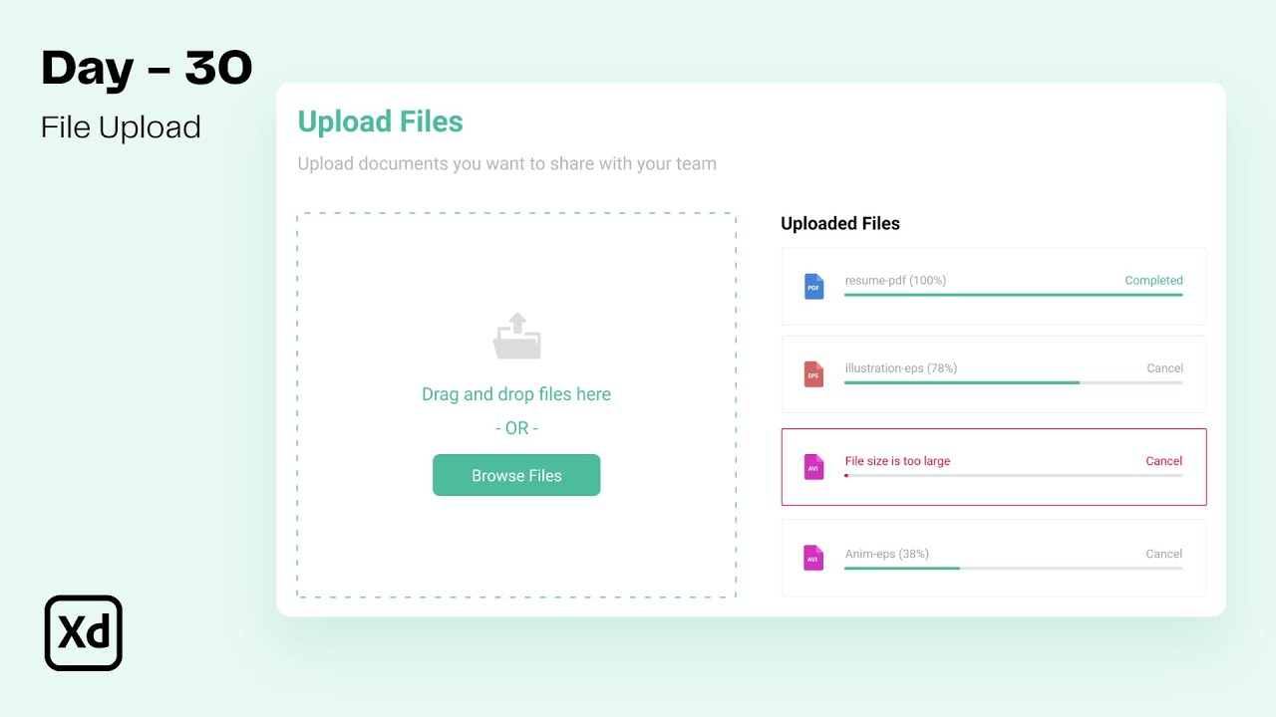

30

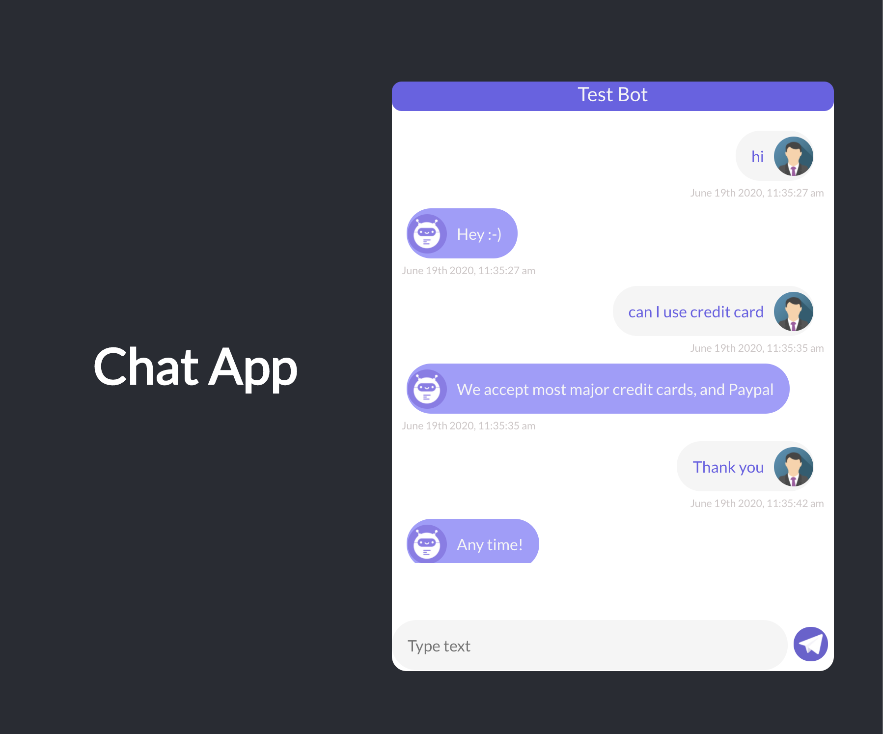

31

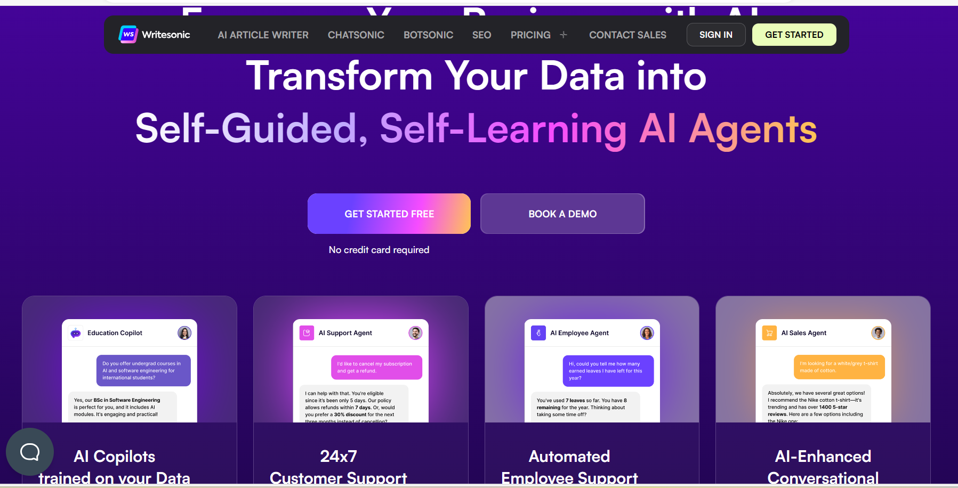

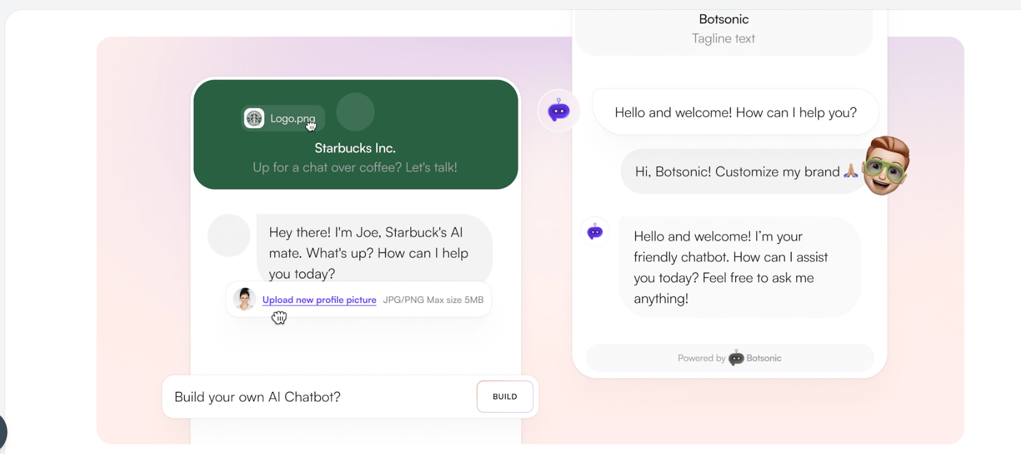

32

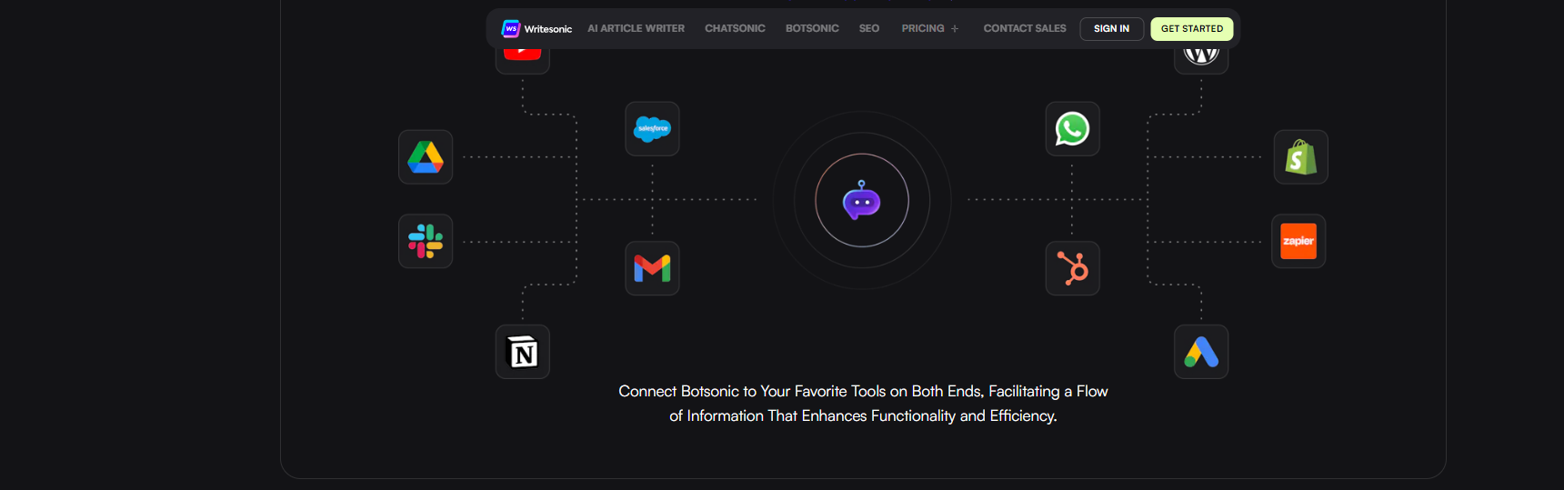

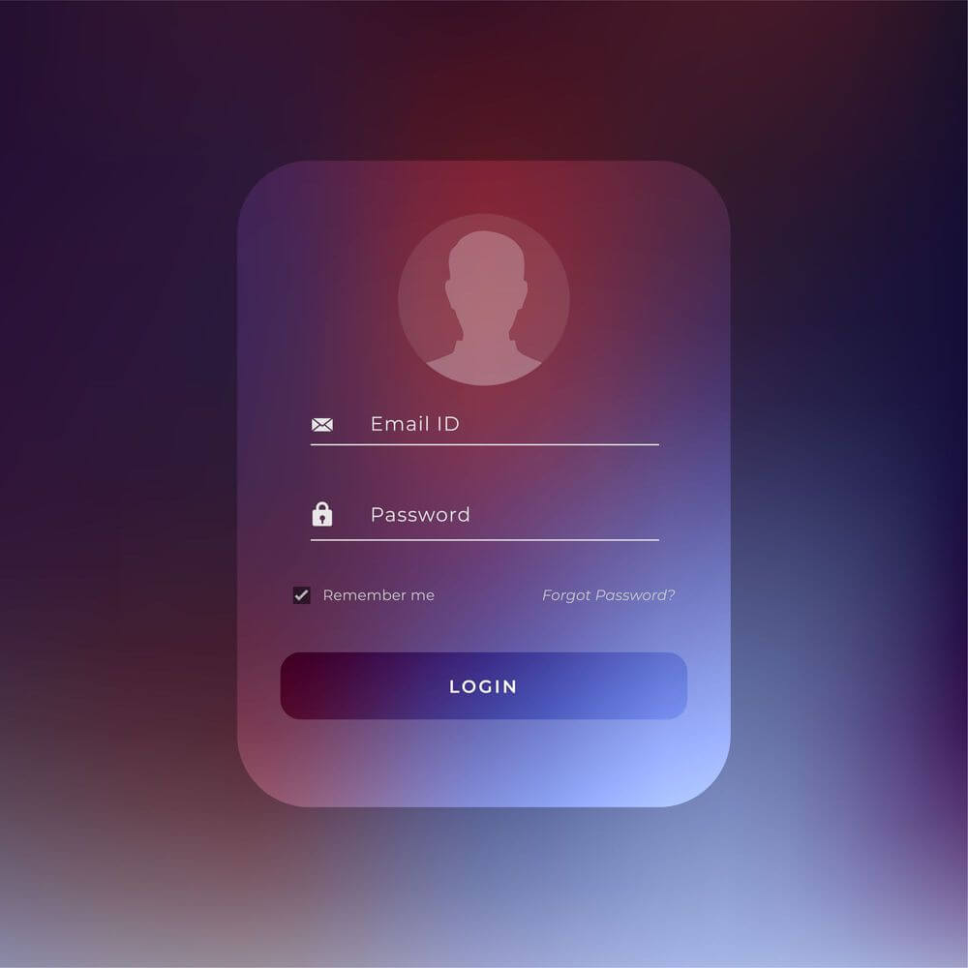

33

**My Contribution**

* Worked on Frontend technologies and UI using React JS to design a creative Introduction/Landing page for Chatbot Service.
* Designed a document upload to upload pdf, docx, images which is stored as a history.
* Designed a Chatbot-chat window where a user is able to send message and get a bot-response.
* Used **‘Dialogflow’**, a Natural Language Platform to train the user and bot-response (text responses).
* **Firebase Realtime Database** - Designed a Login-Form where once a user is authenticated, Firebase Authentication automatically manages user sessions and provides a unique user ID for each authenticated user.

**Technology used:**

* React JS
* Firebase Realtime Database/Authentication
* Dialogflow (Natural Language Platform)

34

**NEW TECHNOLOGIES LEARNT –**

1. **DIALOGFLOW**

* Google Cloud’s **‘Dialogflow’** is a natural language understanding platform developed by Google that enables developers to design and build conversational interfaces, such as chatbots and virtual agents.
* It allows developers to create conversational interfaces that can understand natural language input from users and provide appropriate responses.
* **Agents:**

An **agent** in Dialogflow represents a virtual agent or conversational interface that can understand and respond to user queries.

Agents are designed to interpret user input (text or voice) and provide appropriate responses based on predefined knowledge and logic.

Each agent consists of various components, including intents, entities, contexts, and fulfillment, which collectively enable it to understand and respond to user queries effectively.

* **Intents:**

**Intents** define the purpose or goal of a user's input in a conversation. They represent what the user wants to achieve or inquire about.

Intents also specify the actions or responses that the agent should take when a user's input matches the intent.

By defining and configuring intents within agents, developers can create robust conversational experiences that effectively understand and respond to user queries.

35

* **EXAMPLES:**

The **Default Welcome Intent** is triggered when a user starts a conversation with your agent. It's typically the first interaction users have with your agent. This intent is used to greet users.

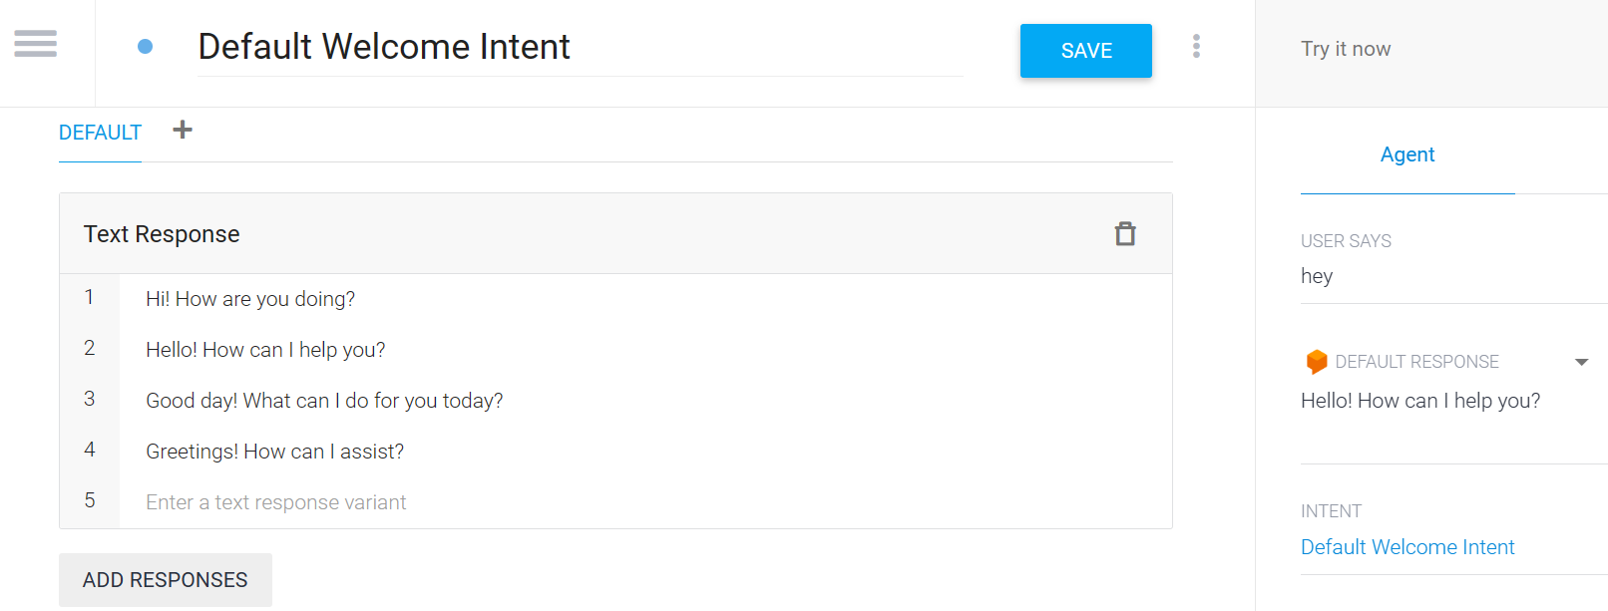

36

The **Default Fallback Intent** is triggered when Dialogflow is unable to match user input to any of the defined intents in your agent. This intent acts as a safety net to handle unexpected or unrecognized user queries.

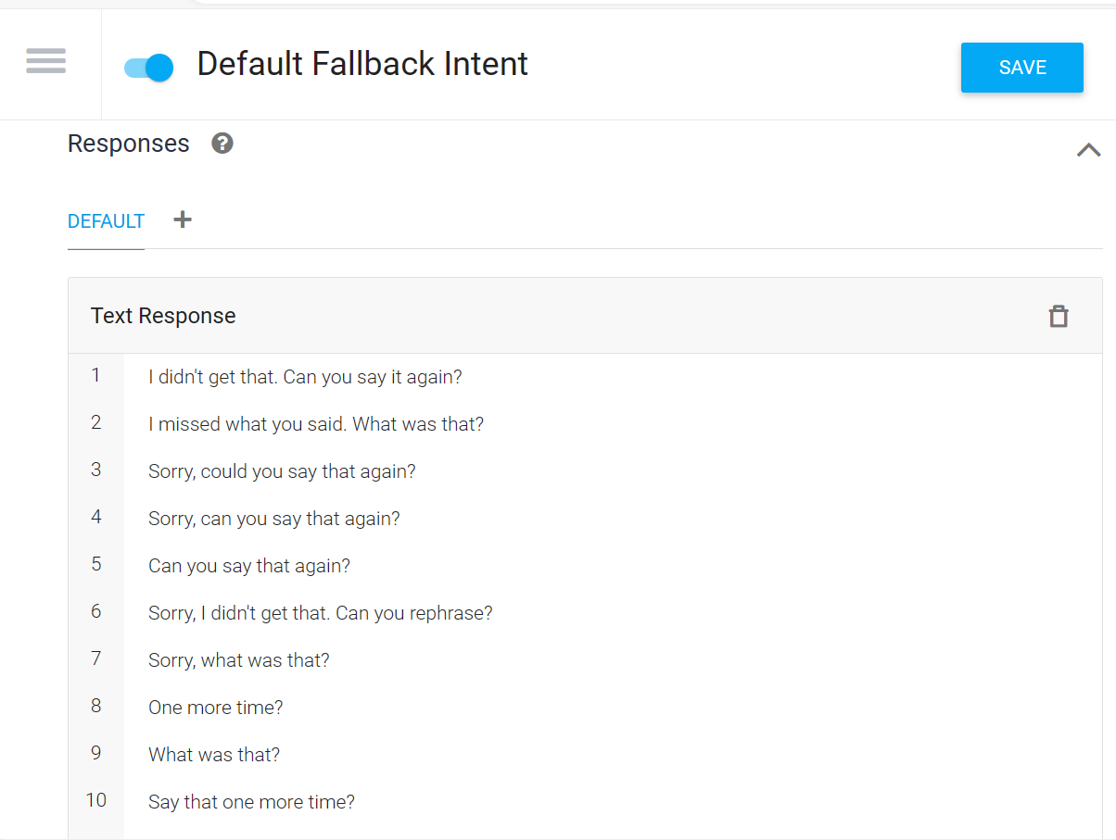

37

**USER RESPONSES:**

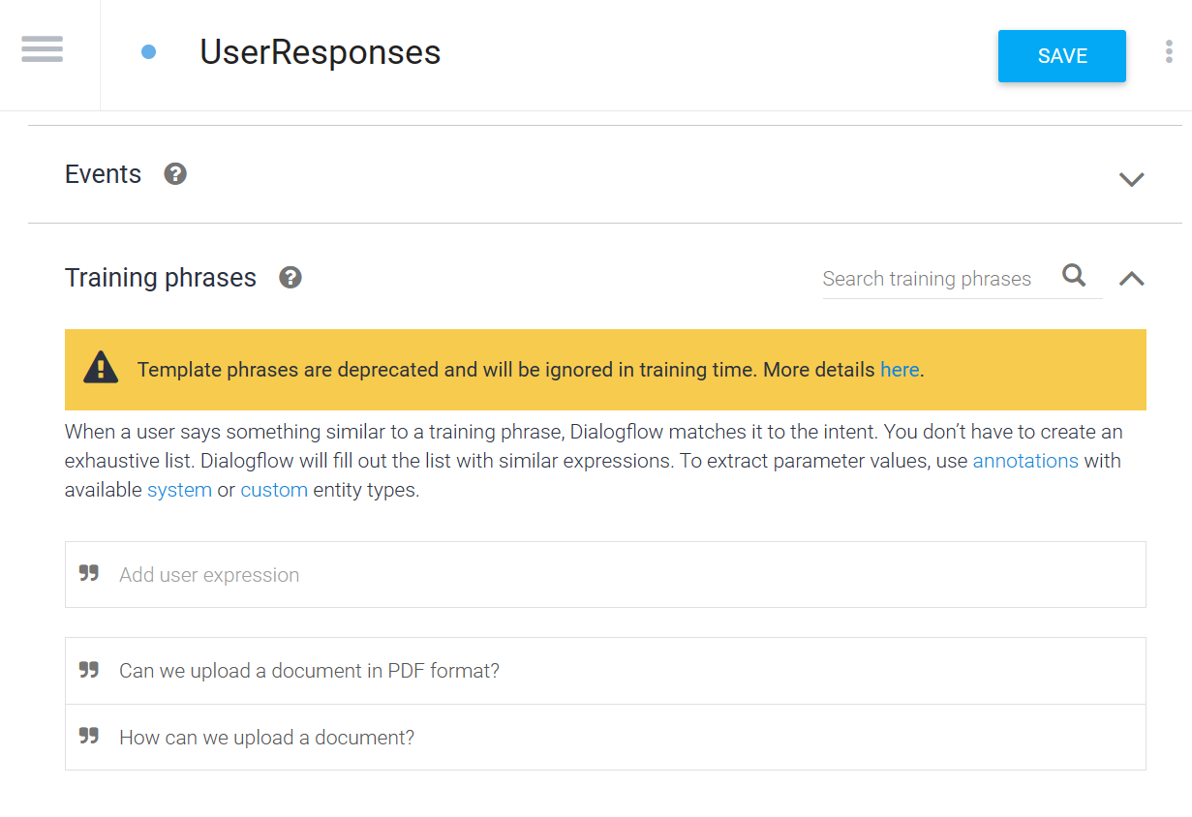

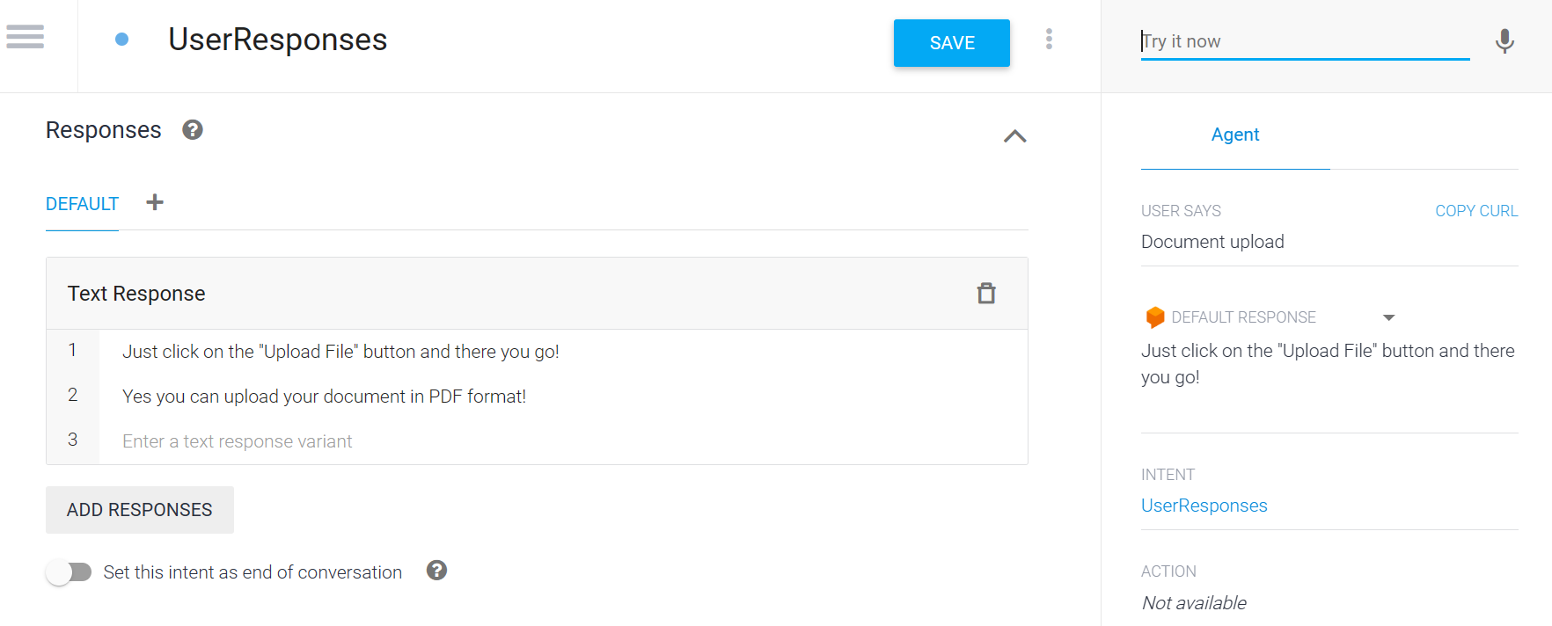

38

**FIREBASE-AUTHENTICATION**

**‘Firebase Authentication’** allows users to sign up and sign in to your application using various authentication providers. Users can create accounts with email/password credentials or sign in with their existing accounts.

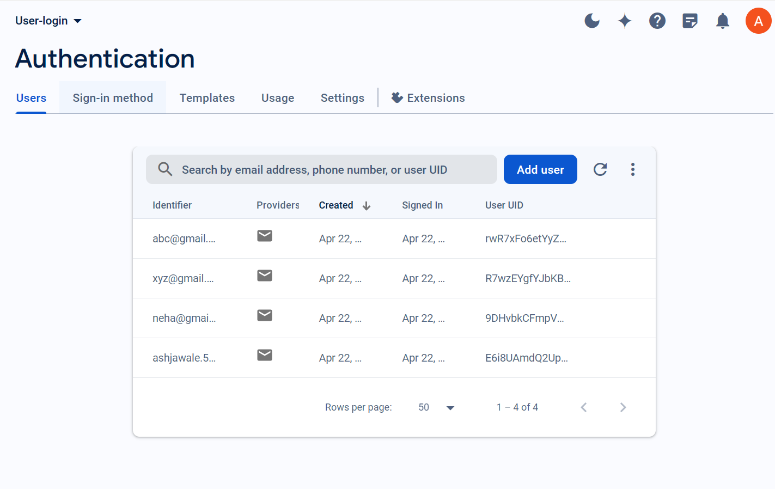

39

**TESTING**

#### Importance of testing:

#### Identifying Defects: Testing helps identify defects or bugs in software, ensuring that they are caught before reaching end-users. This improves the overall quality and reliability of the product.

#### Ensuring Functionality: Testing ensures that the software functions as intended and meets the specified requirements. It verifies that all features work correctly and perform the desired actions.

#### Enhancing User Experience: Testing ensures that the software functions as intended and meets the specified requirements. It verifies that all features work correctly and perform the desired actions.

#### Maintaining Stability: Testing helps maintain the stability and performance of software systems. It identifies potential performance bottlenecks, security vulnerabilities, and compatibility issues, allowing developers to address them proactively.

#### Reducing Costs: Detecting and fixing defects early in the development lifecycle is more cost-effective than addressing them after the product has been released. Testing helps minimize the cost of rework and potential damages caused by software failures.

* **Building Confidence:** Thorough testing instills confidence in both developers and users regarding the reliability and functionality of the software. It provides assurance that the product meets quality standards and can be relied upon for its intended purposes.

#### 40

#### Types of testing:

* **Unit Testing:** This involves testing individual components or modules of the software in isolation to ensure they function correctly. It typically involves testing functions, methods, or classes.
* **Integration Testing:** Integration testing verifies that different modules or components of the software work together as expected when integrated. It focuses on interactions between these modules to identify any inconsistencies or errors.
* **System Testing:** System testing evaluates the entire system as a whole to ensure that it meets specified requirements and functions as intended. It tests both functional and non-functional aspects of the system.
* **Acceptance Testing:** Acceptance testing involves validating the software against business requirements and user expectations. It typically includes user acceptance testing (UAT), where end-users verify that the software meets their needs and performs as expected in their environment.
* **Regression Testing:** Regression testing ensures that recent changes or additions to the software do not adversely affect existing functionality. It involves retesting previously tested features to detect any regressions or unintended side effects.
* **Performance Testing:** Performance testing evaluates the speed, responsiveness, and stability of the software under various conditions, such as different user loads or network conditions. It helps identify performance bottlenecks and ensures that the software meets performance requirements.
* **Security Testing:** Security testing assesses the software's resilience to security threats and vulnerabilities. It includes testing for potential vulnerabilities such as SQL injection, cross-site scripting (XSS), and authentication flaws.
* **Usability Testing:** Usability testing evaluates the software's user interface (UI) and user experience (UX) to ensure that it is intuitive, easy to use, and meets user needs. It involves gathering feedback from representative users through observation and user interviews.

41

* **Compatibility Testing:** Compatibility testing verifies that the software functions correctly across different platforms, devices, browsers, and operating systems. It ensures that the software is compatible with a wide range of configurations and environments.
* **TEST CASES:**

|  |  |  |
| --- | --- | --- |
| **FIELD** | **TYPE** | **DESCRIPTION** |
| User UID | INT | Primary Key |
| Email | VARCHAR (100) | Email of the User |
| Password | VARCHAR (100) | Encrypted Password of User |

42

**3.DRAWBACKS AND LIMITATION**

* **Accessibility Restrictions:** The "Home of AI Services" project might face constraints as not all users possess devices compatible with contemporary web browsers. This could particularly limit its outreach in regions with outdated technology or less advanced hardware.
* **Reliance on Connectivity:** The project's functionality could be constrained in the absence of a reliable internet connection, presenting difficulties for users in regions with poor connectivity or restricted data access.
* **Privacy Risks:** Managing sensitive data in cloud-based platforms like Firebase raises apprehensions about privacy and security, especially in compliance with regulations like GDPR. This necessitates diligent management of user data and adherence to relevant laws.
* **Sustainment and Enhancements:** Continuously updating the platform with new features, bug fixes, and security upgrades demands sustained maintenance efforts. This ongoing commitment could strain developer resources and pose challenges for long-term sustainability.

43

## 4.FUTURE ENHANCEMENT

#### AI-Driven Support: Integrate AI-powered tools like chatbots and virtual assistants to offer tailored suggestions, address inquiries, and streamline administrative tasks, enhancing user satisfaction and operational efficiency.

#### Enhanced Analytics and Insights: Elevate AI services by incorporating advanced data analytics and insights capabilities to provide actionable intelligence for businesses and individuals, facilitating informed decision-making and performance optimization.

#### IoT Fusion: Explore opportunities for integration with Internet of Things (IoT) devices, such as sensors and smart devices, enabling seamless data collection and real-time analysis, paving the way for innovative AI-driven solutions and services.

#### Strengthened Security Measures: Continuously fortify security protocols to safeguard user data and ensure compliance with evolving privacy regulations, upholding user trust and platform integrity.

44

**5.CONCLUSION**

The **"Home of AI Services"** initiative marks a significant stride in democratizing AI access and enriching user interactions across diverse sectors. By consolidating AI services onto a single platform, the project empowers both businesses and individuals to leverage cutting-edge AI capabilities while optimizing operational effectiveness.

While the project boasts commendable features like seamless integration, a wide array of AI services, and robust user management, it does face hurdles like device compatibility, data privacy considerations, and ongoing maintenance demands. However, with proactive strategies and continual refinement, these obstacles can be effectively navigated, enabling the project to realize its full potential.

In summary, the **"Home of AI Services"** endeavor holds great promise in democratizing AI usage, streamlining processes, and fostering innovation. Through continued development and improvements, the platform stands poised to revolutionize the delivery and experience of AI services, catalyzing progress and advancement across various industries.

45

**6. BIBLIOGRAPHY**

* <https://firebase.google.com/docs>
* <https://reactjs.org>
* https://mui.com/material-ui/
* [Writesonic - Best AI Writer, AI SEO Toolkit & Custom AI Chatbots](https://writesonic.com/)

46

**THANK YOU!**